**Using Chatter**

There is a new Show/Hide Feed button at the top of many pages in Salesforce.com. If the button says “Show Feed” you can click if and it will open the Chatter Feed and show the most recent posts from objects that you are following.

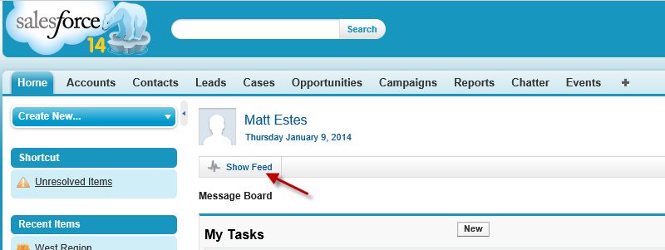

If the button says “Hide Feed” you can click it to collapse the Chatter Feed.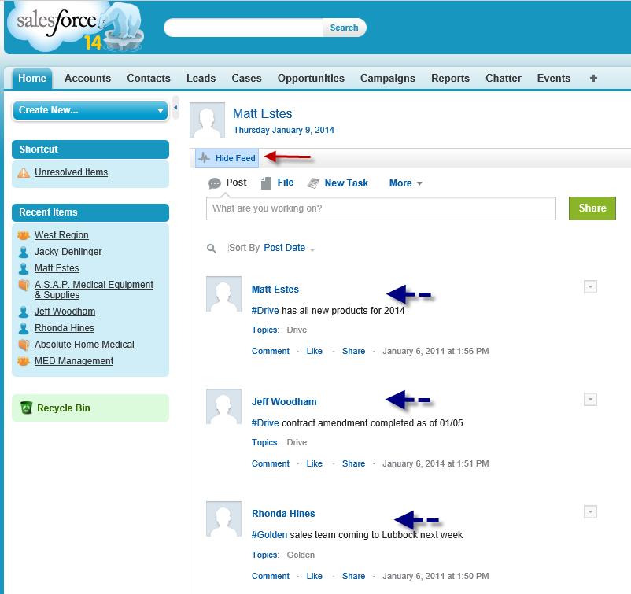

**Adding the Chatter Tab**

Chatter has its own tab that you can add to the top of your Salesforce.com layout to make accessing Chatter easier. To do this, click the “+” at the right side of your tabs.

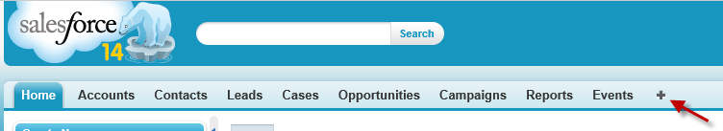

Select “Chatter” under the “Available Tabs” section on the left and click the “Add” button.

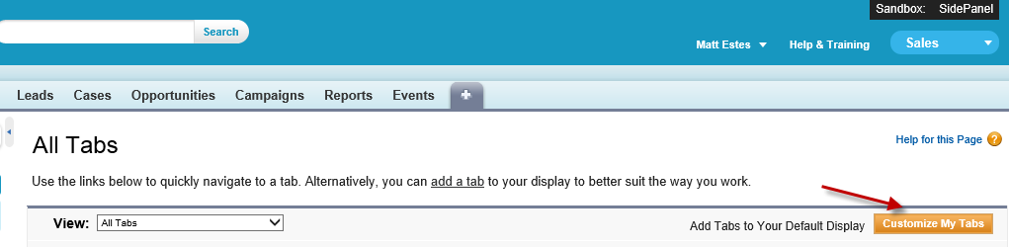

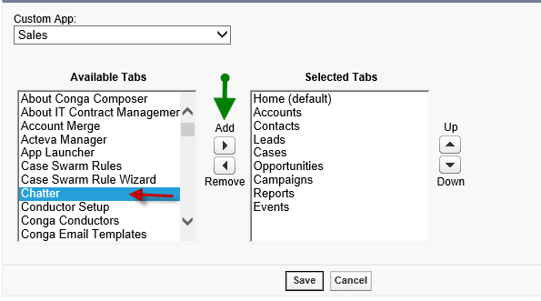

This will move “Chatter” into the “Selected Tabs” section on the right.

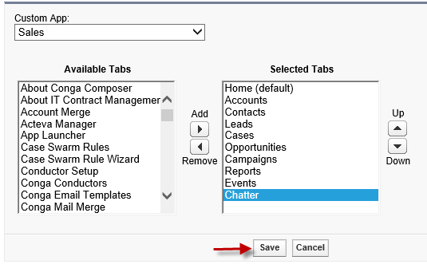

Click the “Save” button to add the Chatter tab to the top of your Salesforce pages.

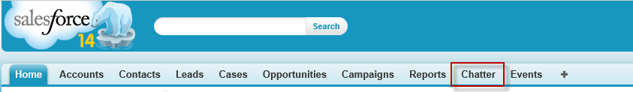

Once you open the Chatter tab you’ll see a list of posts to objects that you follow. 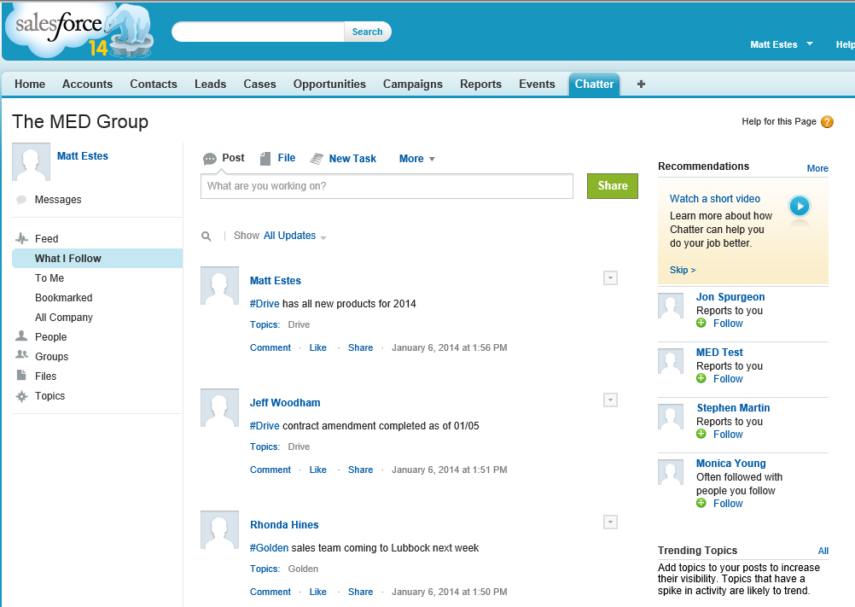

**Feed**

You’ll notice that on the left under *Feed*, “What I Follow” is highlighted. This is the default list that is shown when you open the Chatter tab.

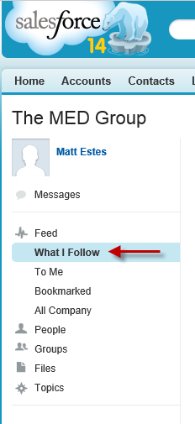

If you select “All Company”, you will see any posts on objects that you have access to in all of Salesforce.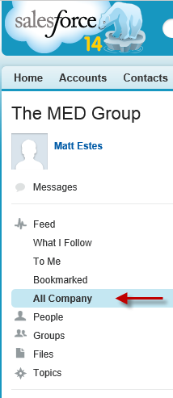

**People**

If you click on *People* on the left it will default to the “Recently Viewed” list. From here you can see who you have recently viewed, who you are following and click  to follow other MED Employees.

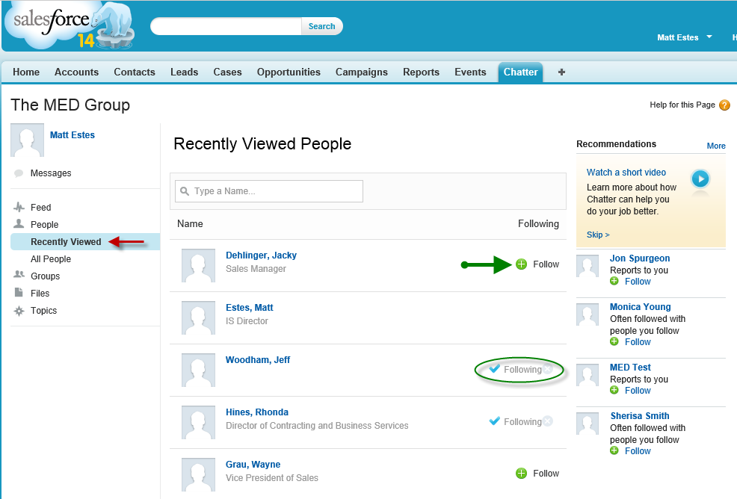

The best place to go to add/remove MED Employees that you follow is by clicking on “All People” under *People* on the left side. This will give you a list of all MED Employees and you can add people to follow by clicking .

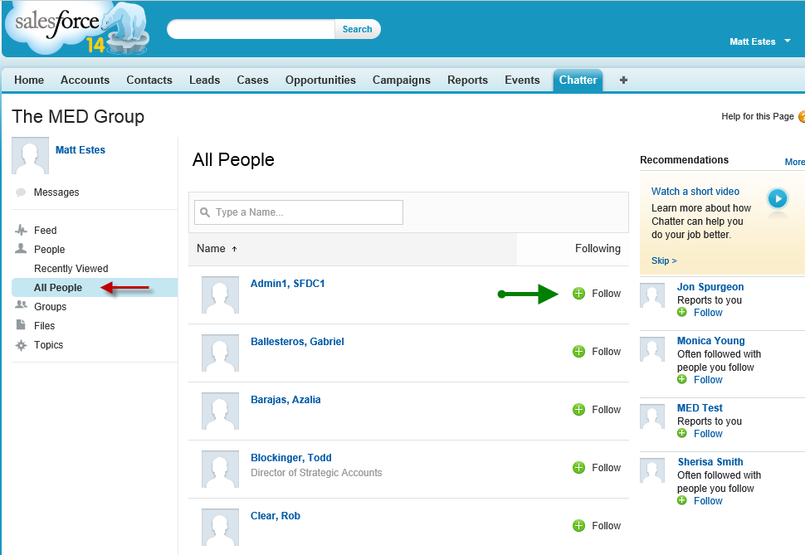

**Groups**

*Groups* are a way to share information on particular topics or within specific departments or cross-functional teams. Groups can be completely public and open for everyone to join, or completely private so discussion are kept confidential. Initially we are not going to be using the Chatter Groups, but they may be turned on at a later date.

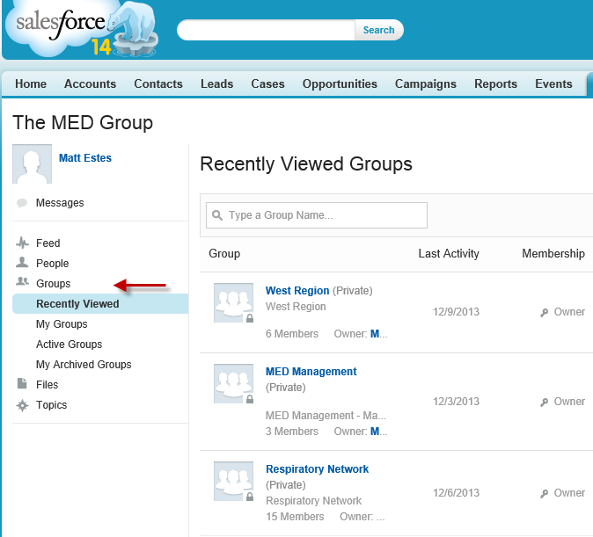

**Files**

By clicking *Files* on the left you can view the files that have been posted to the Chatter Feed.

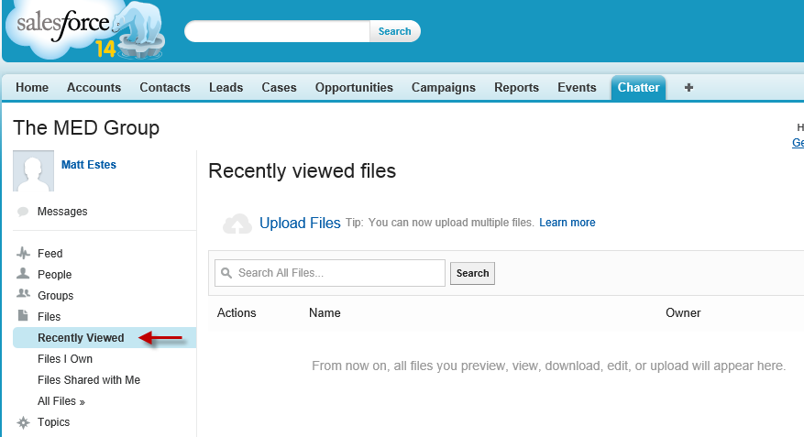

**Topics**

Clicking *Topics* on the left brings you into the “All Topics” category and it will show you a list of any #Topics that have been posted to Chatter Feeds on objects that you have access to.

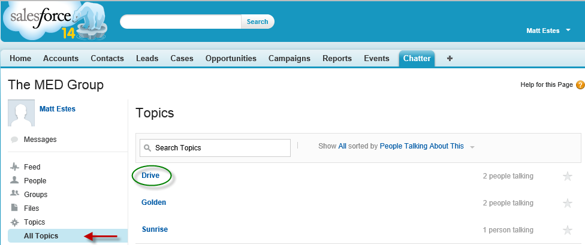

If you click on a Topic on the right, it will show you the posted Feeds that the #Topic is discussed in.

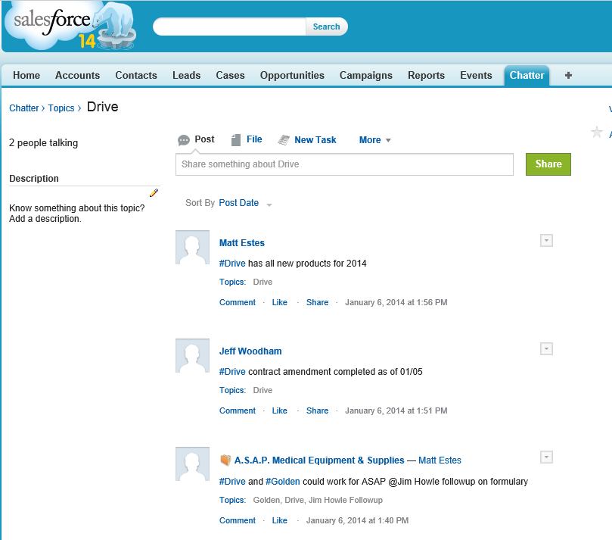

**Posting**

To post an item to the Chatter Feed, make sure that “Post” is selected and type what you want to post into the post box at the top of the Home page or Object page.

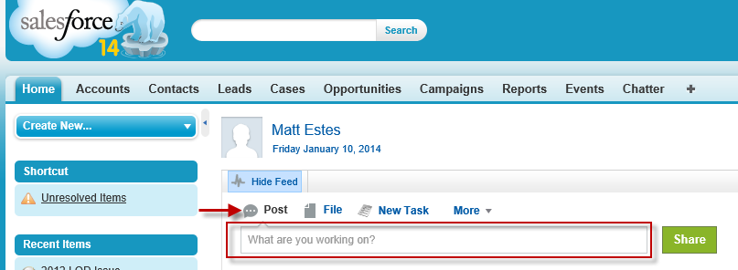

You can use #Topic, i.e. #Drive, to add a topic into your post. #Topics are searchable in Chatter. If the #Topic already exists it will pop-up for you to select at the bottom of the post box.

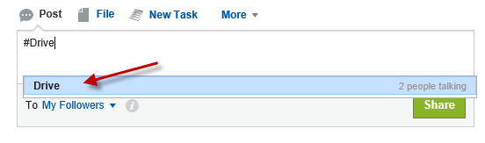

Once the #Topic has been added, Chatter will put brackets around it.

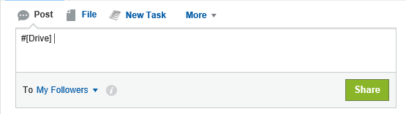

Using @Mention, i.e. @Jeff Woodham, will send an email to the person and alert them that they have been mentioned in a post. As you begin to type in the @Mention, a pop-up list will appear with your options. Select the person you want to @Mention from the pop-up list at the bottom of the post box.

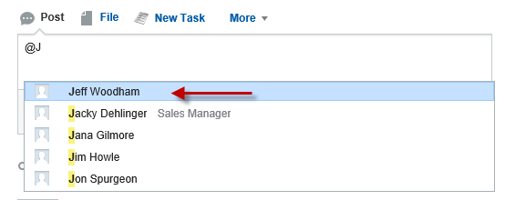

Once they have been selected, Chatter will put brackets around their name.

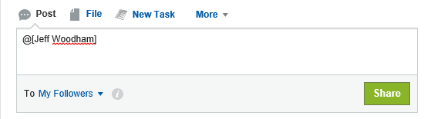

**Email Feed settings**

You can set Chatter to email you a copy of your feed on a daily, weekly or monthly basis. To do this click on your name and then select “Setup”  
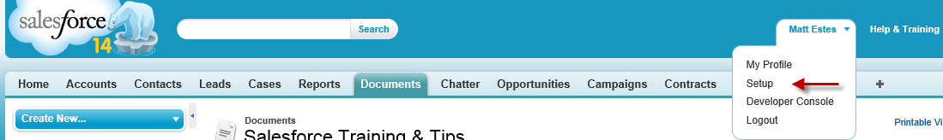

Expand “My Chatter Settings” and select “Chatter Email Settings”.  
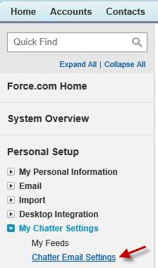

Make sure that “Receive emails” is checked and then select the box for the frequency of your personal digest and click “Save”.

